***S.Keerthana***

***REG.NO.22BEC1503***

**Exp 5: Inverting, Non-Inverting Op-amps & Summer**

***Aim:*** *To perform transient analysis of inverting, non-inverting op-amps and summer using LTSpice software*

***Apparatus Required:*** *LTSpice software*

***Theory:*** *The inverting amplifier is a basic op-amp circuit that provides an inverted output signal relative to the input. It's configured using a single op-amp and two resistors. The input signal is connected to the inverting (-) input of the op-amp, and the feedback resistor is connected between the output and the inverting input. They are commonly used in applications where signal inversion or amplification is required, such as audio amplifiers and waveform generation.*

*The non-inverting amplifier, like the inverting amplifier, is a basic op-amp circuit but provides a non-inverted output relative to the input. In this circuit, the input signal is connected to the non-inverting (+) input of the op-amp, and the feedback resistor is connected between the output and the non-inverting input. They are often used in audio and voltage amplification circuits.*

*An op-amp summer is a circuit that combines multiple input signals into a single output signal, effectively summing the input voltages. It is achieved by connecting multiple input resistors to the inverting (-) input of the op-amp and a feedback resistor from the output to the inverting input. The output voltage of the summer is the weighted sum of the input voltages.*

*They find application in various fields, such as audio mixing, signal processing, and instrumentation, where it's essential to combine multiple signals while maintaining precise control over the relative contributions of each input.*

**Procedure**:

Circuit Diagrams:

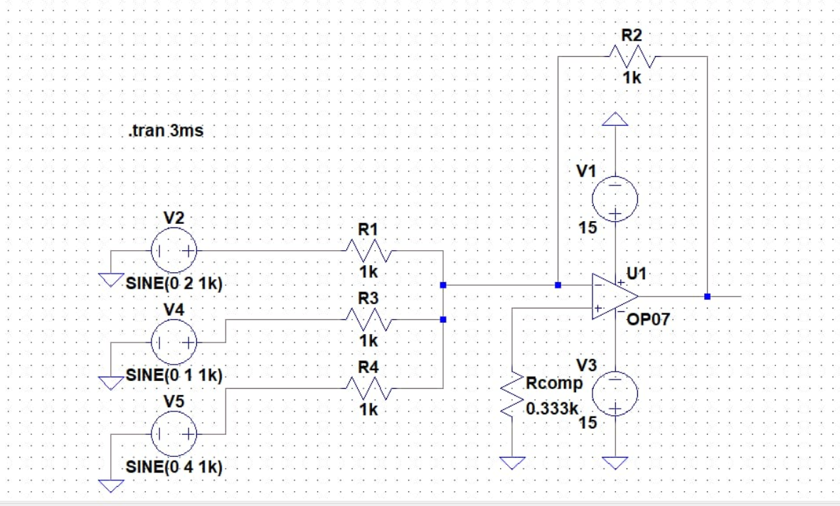

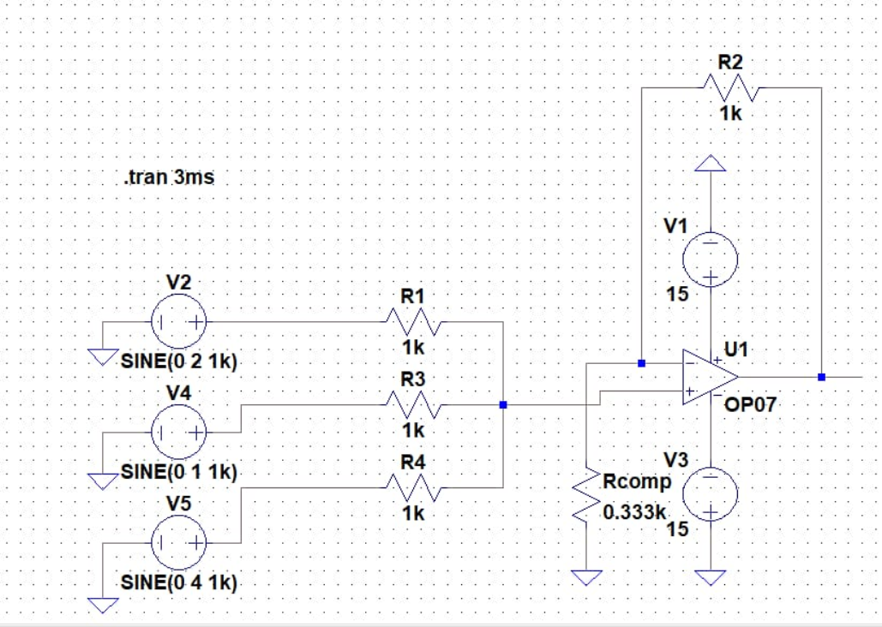

*Simulation Window:*

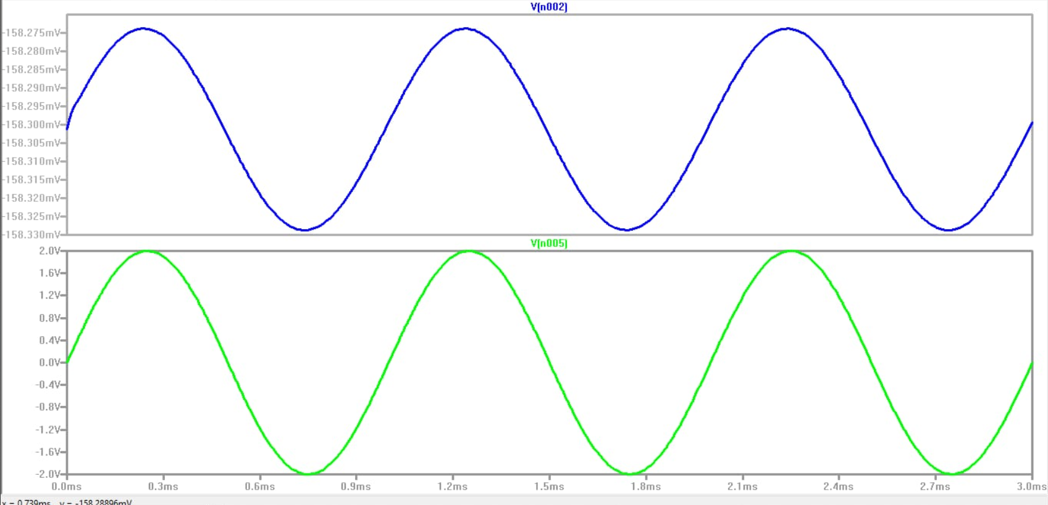

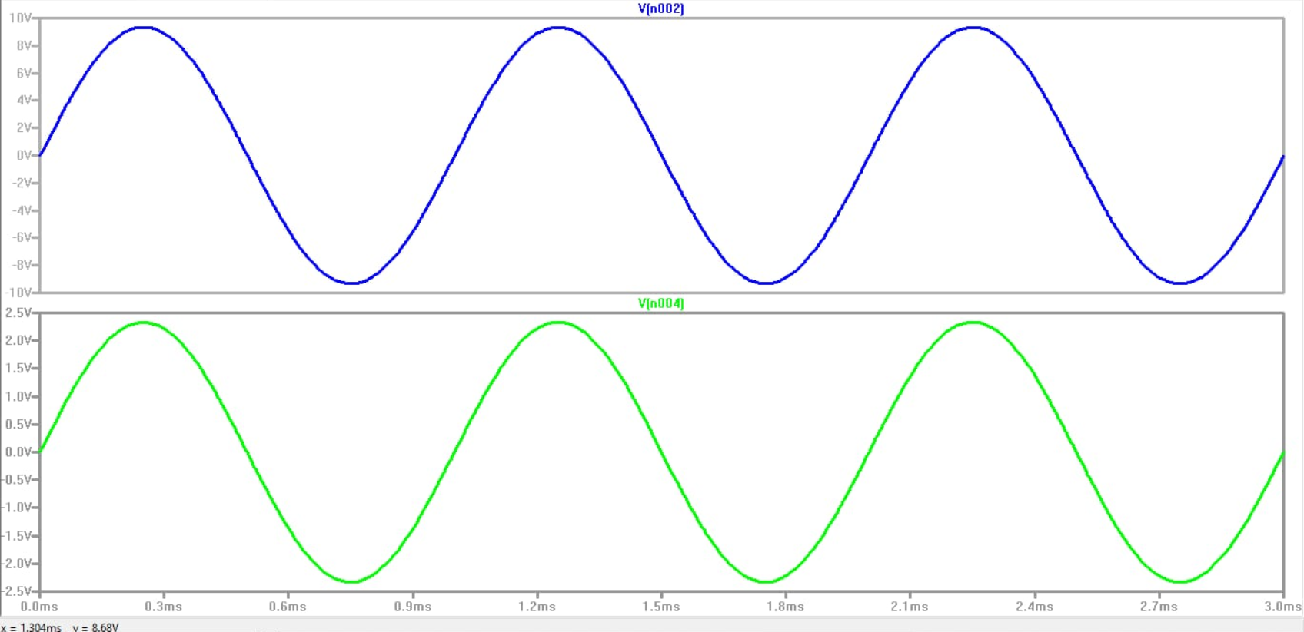

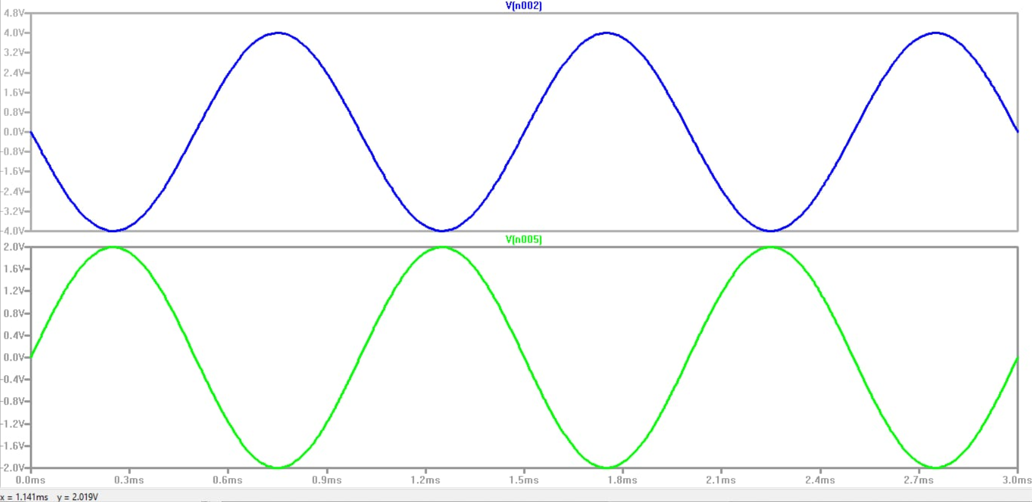

*Circuit Diagram (using lm741):*

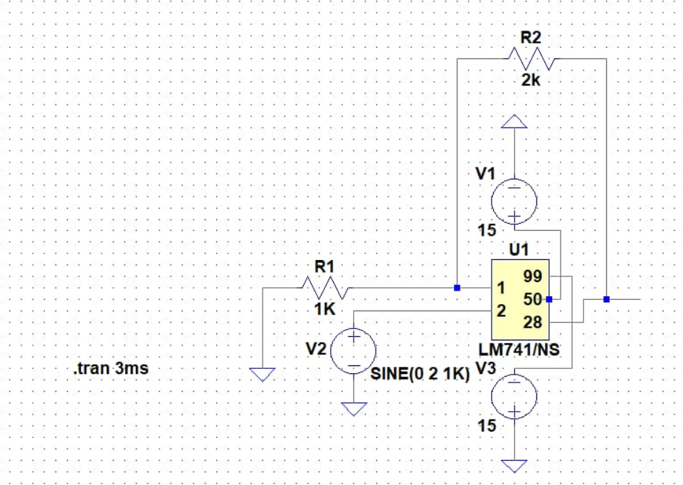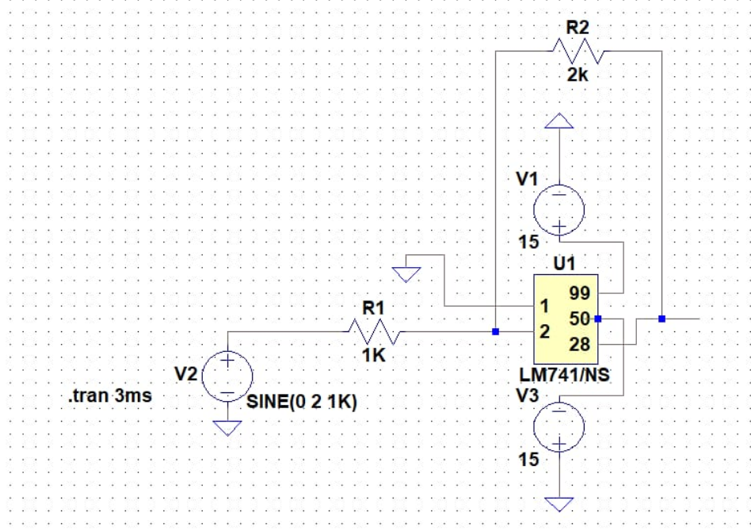

***Result****: Hence the transient characteristics of inverting, non-inverting op-amps and summer are analysed and simulated using LTSpice software.*